# Overview

* A grid based expandable map system is available for the player to build farms and infrastructure.

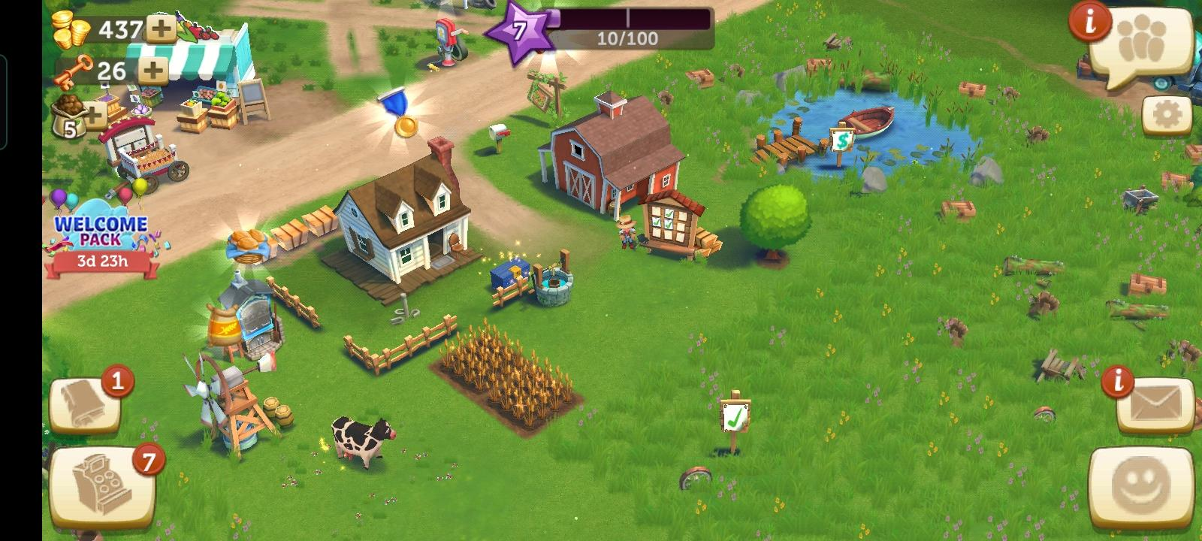

# Building System

* The player starts with one basic tent at the center of their farmland
* The player will use the build panel to select the category of infrastructure they want to build. From the category they can select the buildings and facilities. These buildings are prerequisite for buying animals, machinery and further infrastructure. Players can scroll through panel items using the on screen UI or the scrolling wheel
* 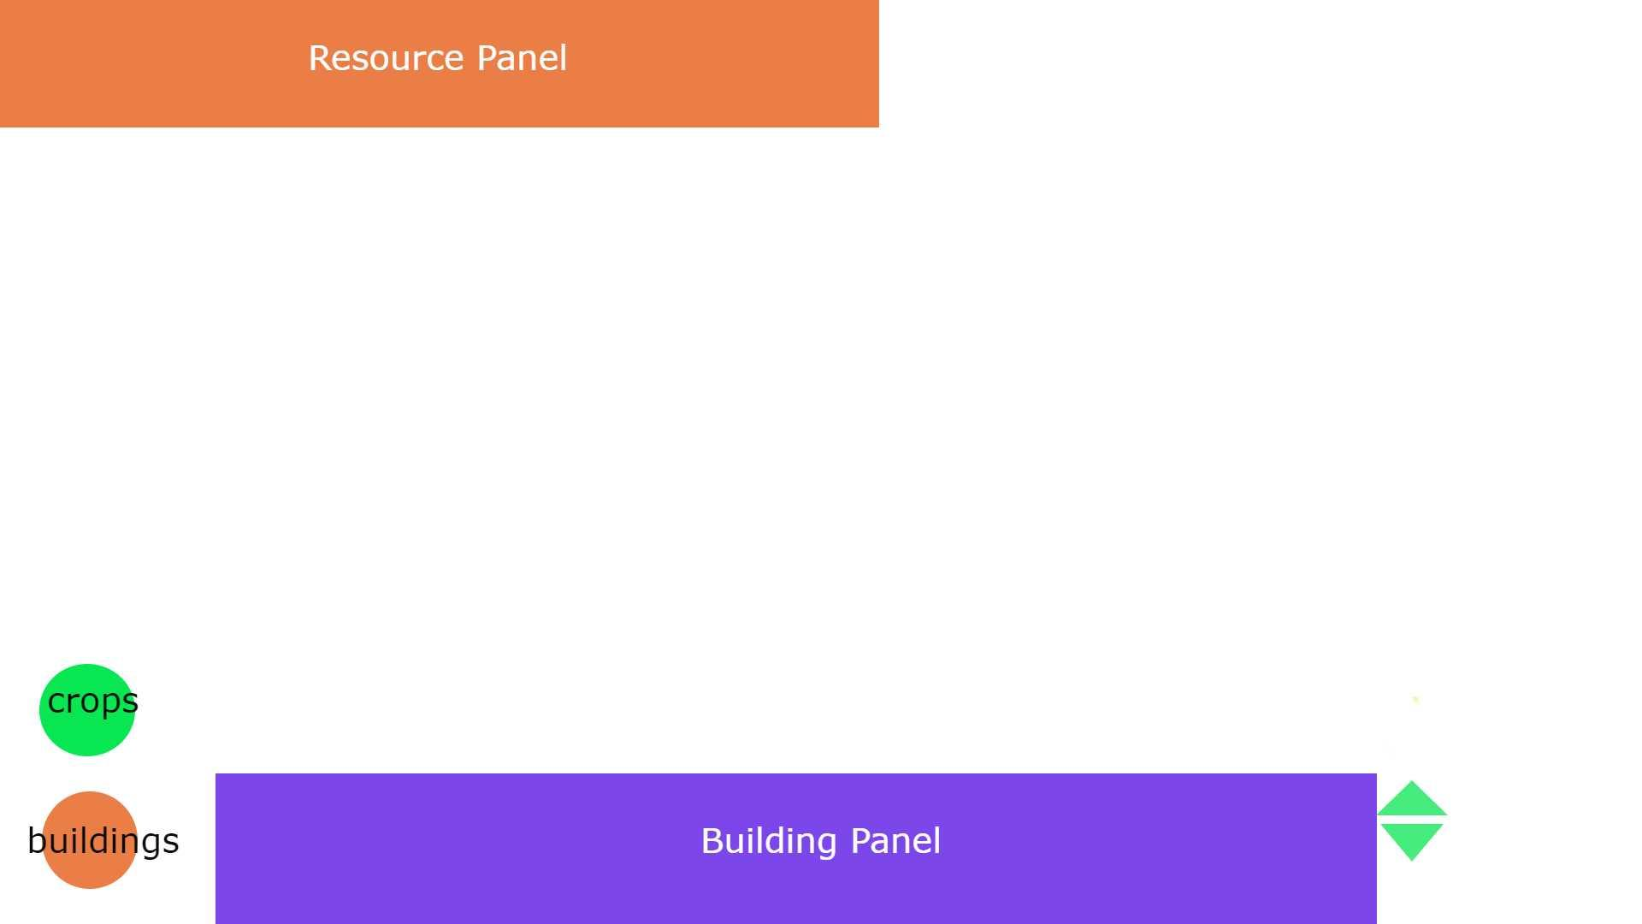
* Some buildings need to be connected to a road.
* Building and upgrading anything will cost diamonds and raw material resources like wood, steel, stones, etc. When the player hovers over the desired building button, its cost is displayed using a tooltip on the UI.

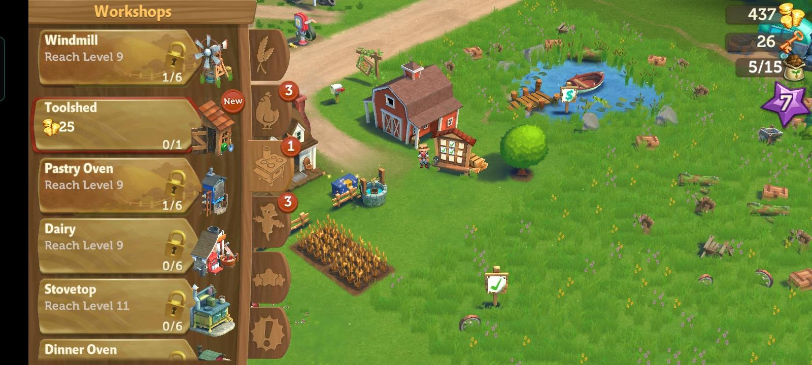

* The players can build and upgrade infrastructure like:
  + Home
  + Farms
  + Barn
  + Granary
  + Dairy
  + Storage
  + Tool shed
  + Cattle sheds and pens
  + Roads
  + Fences
  + Wind and water mill
  + Oven
  + Loom
  + Winery
  + Pottery

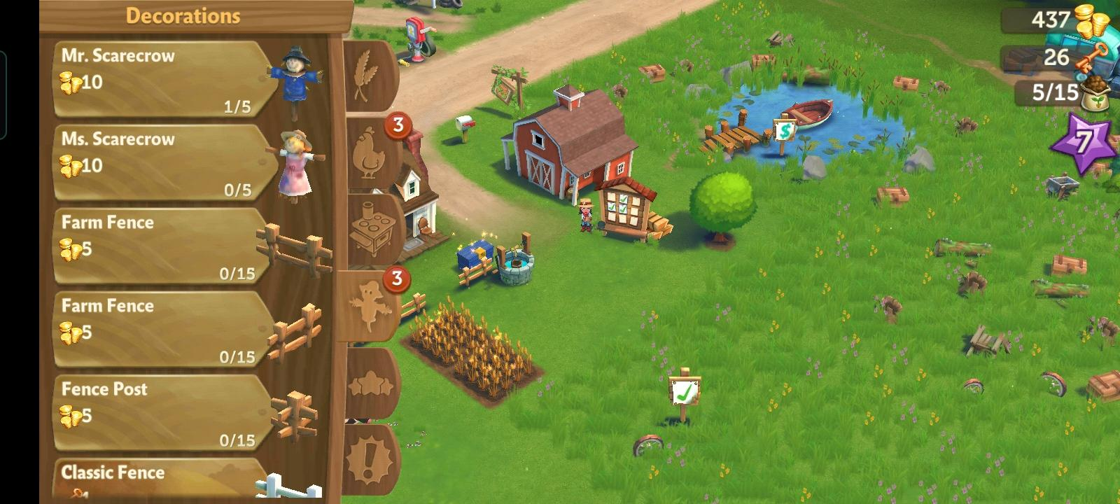

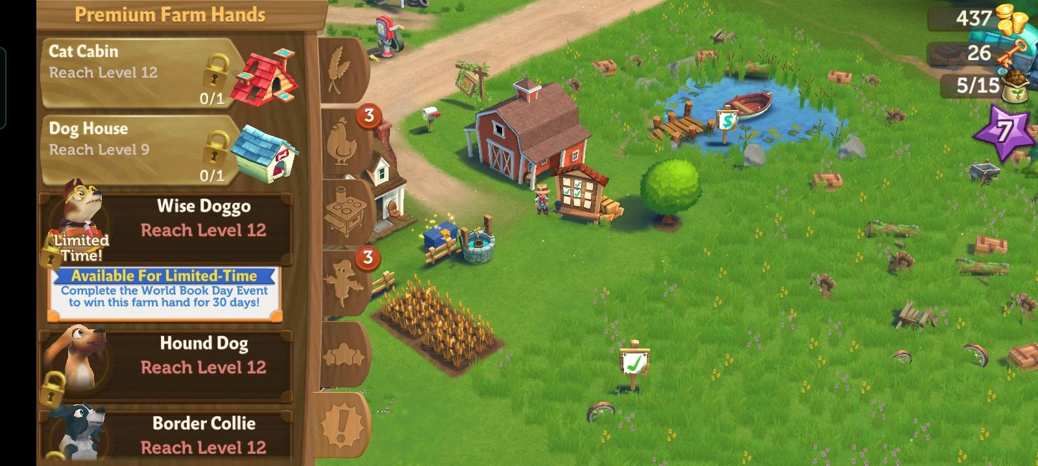

* Once the building is selected, a wireframe projection is used to plan the placement. If the building placement is possible, the tile beneath the projection will have a green highlight. If the placement is not possible, the tile will have a red highlight.

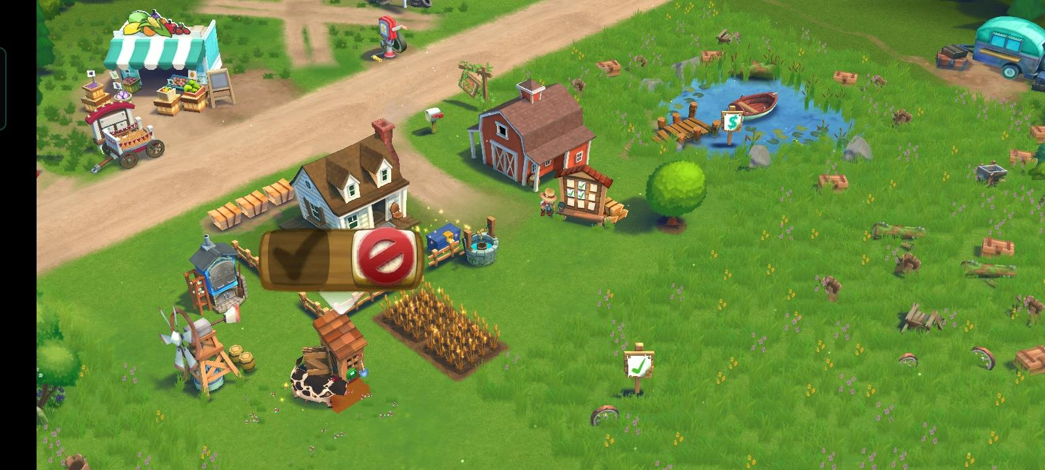

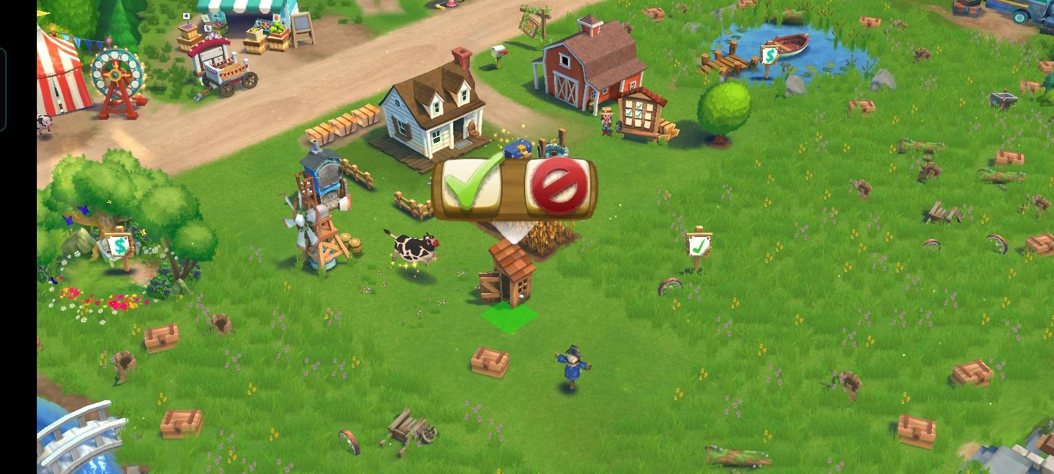

* Using ctrl + right mouse + drag it can be rotated around the y axis as needed. It can be placed using the left mouse button.
* Pressing right click will deselect the selected building.
* Different buildings will require a different number of tiles.
* These buildings will also be required to repair and maintain from time to time with use.
* Uneven terrain needs to be bulldozed and leveled before building on them
* Bulldozers need to be maintained after a few number of uses.
* Players can move and rotate their buildings without any cost on leveled terrain.
* Buildings cannot be placed or moved on uneven terrain.
* Players can purchase additional land to expand their farm. This will be possible in the form of locked tiles that can be unlocked using diamonds.
* Destroying a building or facility will require diamonds and ~70% resources will be lost.

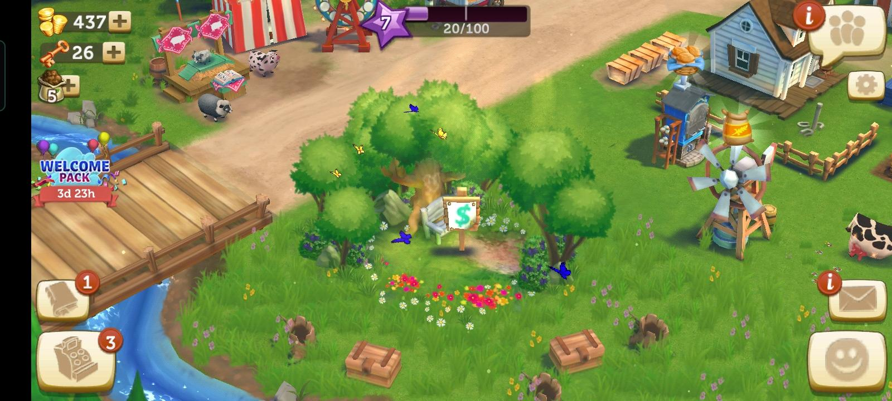

# Exposed Variables

* Different construction duration for each different building
* Different cost of each different building and infrastructure